**BANK LOAN REPORT QUERY DOCUMENT**

1. **BANK LOAN REPORT | SUMMARY**

create database bank;

use bank;

rename table financial_loan to loan;

**KPI’s:**

Total Loan Application

select count(ID) as total_loan_application from loan;

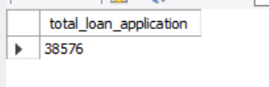

MTD Loan Application (Month to date application)

select count(issue_date) as MTD_loan_application from loan

where issue_date like ("%-12-2021");

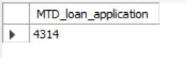

PMTD Loan Application (Previouse month application)

select count(issue_date) as p_month_loan_application from loan

where issue_date like ("%-11-2021");

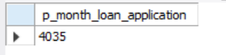

**(mtd - pmtd / pmtd) =mom**

Funded amount

Total Funded Amount

select SUM(loan_amount) AS total_funded_amount from loan;

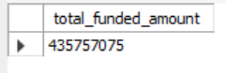

PMTD Funded Amount (Previouse Funded Amount)

select sum(loan_amount) as PMTD_total_funded_amount from loan

where issue_date like ("%-11-2021");

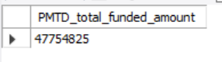

MTD Funded Amount (Month to date Funded Amount)

select sum(loan_amount) as MTD_total_funded_amount from loan

where issue_date like ("%-12-2021");

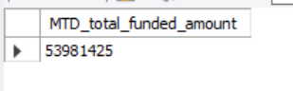

**Total Amount Received**

selecT SUM(total_payment) AS total_amount_recieved from loan;

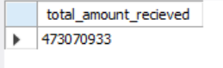

**PMTD** **Amount Received**

select sum(total_payment) as PMTD_amount_recieved from loan

where issue_date like ("%-11-2021");

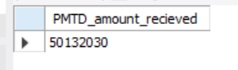

MTD **Total Amount**

select sum(total_payment) as MTD_total_amount_recieved from loan

where issue_date like ("%-12-2021");

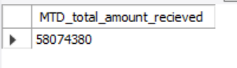

**Average Interest Rate**

select avg(int_rate) * 100 AS avg_interest_rate from loan;

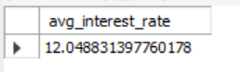

PMTD **Average Interest Rate**

select avg(int_rate) * 100 as PMTD_avg_interest_rate from loan

where issue_date like ("%-11-2021");

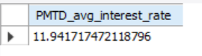

MTD **Average Interest Rate**

select avg(int_rate) * 100 as MTD_avg_interest_rate from loan

where issue_date like ("%-12-2021");

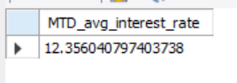

**Avg DTI**

select avg(dti) * 100 AS avg_interest_rate from loan;

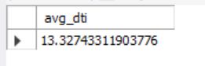

PMTD **Avg DTI**

SELECT

AVG(dti) * 100 AS PMTD_avg_dti

FROM loan

WHERE issue_date LIKE ('%-11-2021');

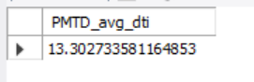

**MTD Avg DTI**

select avg(int_rate) * 100 as MTD_avg_dti from loan

where issue_date like ("%-12-2021");

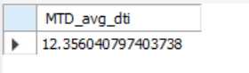

**Good Loan Issued**

**Good Loan Percentage**

select

count(case when

loan_status in ("Fully Paid" , "Current" ) then id end) * 100 /

count(id) as Good_loan_application from loan;

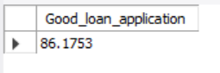

**Good Loan Applications**

select count(id) from loan

where loan_status="Fully Paid" or loan_status="Current";

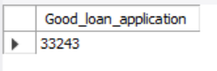

**Good Loan Funded Amount**

select sum(loan_amount) as Good_Loan_Funded_Amount from loan

where loan_status="Fully Paid" or loan_status="Current";

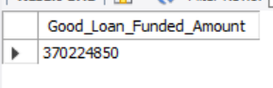

**Good Loan Amount Received**

select sum(total_payment) as Good_Loan_Total_Received_Amount from loan

where loan_status="Fully Paid" or loan_status="Current";

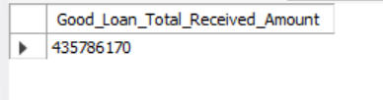

**Bad Loan Issued:**

**Bad Loan Percentage**

select count(case when loan_status ='Charged Off' then id end) * 100 / count(id) as bad_loan_application from loan;

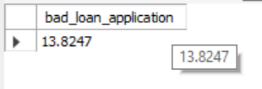

**Bad Loan Applications**

select count(id) as bad_loan_application from loan

where loan_status='Charged Off';

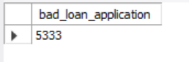

**Bad Loan Funded Amount**

select sum(loan_amount) as bad_Loan_Funded_Amount from loan

where loan_status='Charged Off';

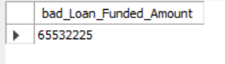

**Bad Loan Amount Received**

select sum(total_payment) as bad_Loan_Total_Received_Amount from loan

where loan_status='Charged Off';

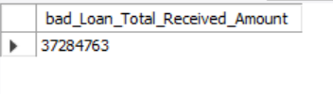

**LOAN STATUS**

SELECT

loan_status,

COUNT(id) AS LoanCount,

SUM(total_payment) AS Total_Amount_Received,

SUM(loan_amount) AS Total_Funded_Amount,

AVG(int_rate * 100) AS Interest_Rate,

AVG(dti * 100) AS DTI

FROM bank_loan_data

GROUP BY loan_status

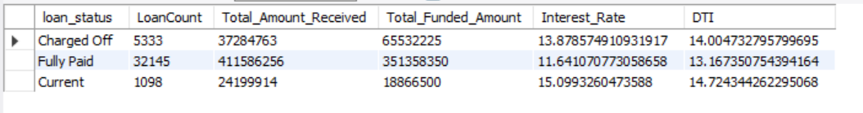

select loan_status,

sum(total_payment) as MTD_Total_Amount_Received,

sum(loan_amount) as MTD_Total_Funded_Amount

from loan

where issue_date like ("%-12-2021")

group by loan_status;

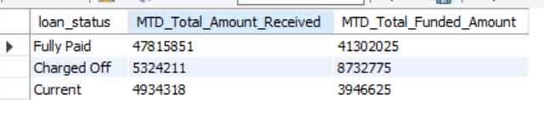

select loan_status,

sum(total_payment) as PMTD_Total_Amount_Received,

sum(loan_amount) as PMTD_Total_Funded_Amount

from loan

where issue_date like ("%-11-2021")

group by loan_status;

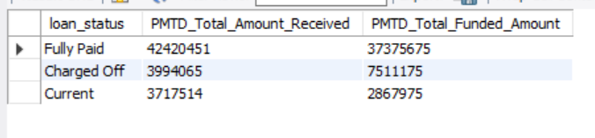

Dashboard – 2

1. **BANK LOAN REPORT | OVERVIEW**

**MONTH**

SELECT

MONTH(issue_date) AS Month_Munber,

DATENAME(MONTH, issue_date) AS Month_name,

COUNT(id) AS Total_Loan_Applications,

SUM(loan_amount) AS Total_Funded_Amount,

SUM(total_payment) AS Total_Amount_Received

FROM bank_loan_data

GROUP BY MONTH(issue_date), DATENAME(MONTH, issue_date)

ORDER BY MONTH(issue_date)

**STATE**

SELECT

address_state,

COUNT(id) AS total_loan_application,

SUM(loan_amount) AS total_funded_amount,

SUM(total_payment) AS total_received_amount

FROM loan

GROUP BY address_state

ORDER BY sum(address_state) desc;

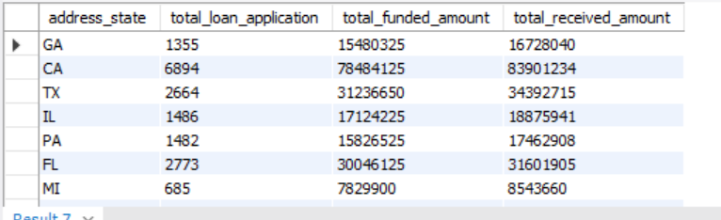

**EMPLOYEE LENGTH**

SELECT

emp_length,

COUNT(id) AS total_loan_application,

SUM(loan_amount) AS total_funded_amount,

SUM(total_payment) AS total_received_amount

FROM loan

GROUP BY emp_length

ORDER BY emp_length desc;

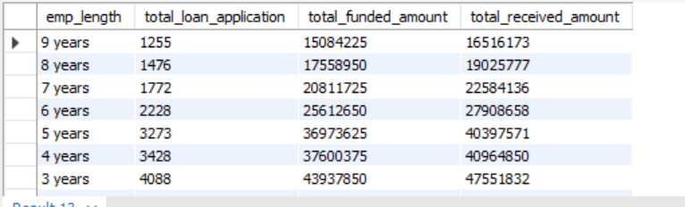

**Purpose**

SELECT

purpose,

COUNT(id) AS total_loan_application,

SUM(loan_amount) AS total_funded_amount,

SUM(total_payment) AS total_received_amount

FROM loan

GROUP BY purpose

ORDER BY count(id) desc;

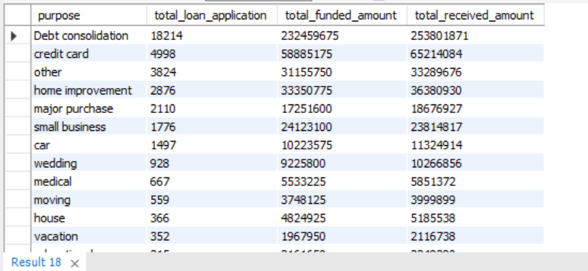

**Home Ownership:**

SELECT

home_ownership,

COUNT(id) AS total_loan_application,

SUM(loan_amount) AS total_funded_amount,

SUM(total_payment) AS total_received_amount

FROM loan

GROUP BY home_ownership

ORDER BY count(id) desc;

